Naming:

Peripheral
Accessory
Tool->Instrument, Device
Element-> Component

Purpose
Justification

Attribute / Property / Fields:

Ticket No:
2011-001

Justification:
- Newly Joined
- Replacement (Outdated)
- Replacement (Out of Order)
- Replacement (Stolen)

Status:
- Submitted
- Working
- Done
- Cancelled

Priority:
- Urgent
- High
- Mid
- Low

ITEquipmentType:
- TypeID (PK)
- TypeCode
- TypeName
- MISStoreQty
- UserEndQty
- DefectiveQty
- RepairQty

ITEquipmentFeature:
- TypeID
- FeatureName

ITEquipment:
- EquipmentID
- TypeID
- AssetTag
- Brand
- ModelNo
- SerialNo
- ProductNo
- SupplierID
- PurchaseDate
- DiscardDate
- CompanyID
- CurDepartmentID
- CurEmplyeeID
- Status
  - Stored
  - Allotted
  - Defective
  - Discarded
- Remarks
- StoreID [Enum: MIS, User, Defective, Repair]

ITEquipmentDetails:
- EquipmentID
- FeatureName
- FeatureValue

ITEquipmentTran:
- TranID (PK)
- TranDate
- TranType [Purchase, Assign, Return to MIS, Return to Supplier, Get back from Supplier, Defect, Discard]
- EquipmentTypeID
- EquipmentID [null]
- EmployeeID [null]
- DepartmentID [null]
- CompanyID [null]
- FromStoreID
- ToStoreID
- Qty
- Remarks

- Activity flow diagram for IT Equipment Transactions –
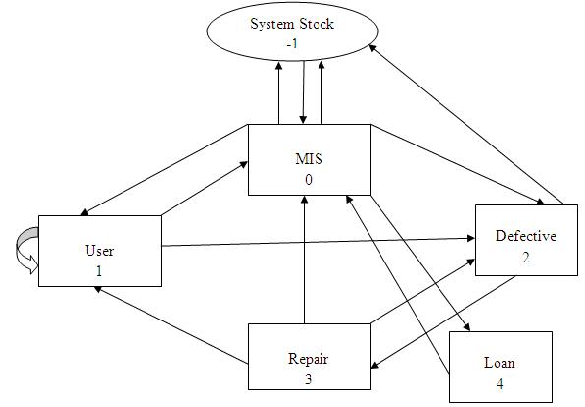

Description
Event | Event Type | From Stock | To Stock
System to MIS | Purchase | -1 | 0
MIS to System | Return Supplier | 0 | -1
System to MIS | Get back Supplier | -1 | 0
MIS to User | Assign to User | 0 | 1
MIS to Defective | Defect | 0 | 2
User to MIS | Return MIS | 1 | 0
User to User | Assign to User | 1 | 1
User to Defective | Defect | 1 | 2
Defective to Repair | Repair | 2 | 3
Defective to System | Discarded | 2 | -1
Repair to User | Assign to User | 3 | 1
Repair to MIS | Return MIS | 3 | 0
Repair to Defective | Defect | 3 | 2
MIS to Loan | Assign to User | 0 | 4
Loan to MIS | Return MIS | 4 | 0

